How to Access the Welnet Website

Step 1 – Visit the Focused Fitness Website
Step 2 – Enter the login information provided by your Healthful Living teacher in the Welnet area on the bottom-left of the page | 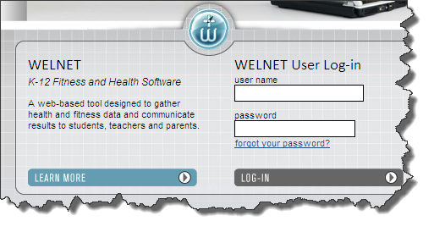
Step 3 – Click the Fitness tab on the left side of the page | 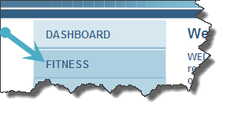
Step 4  Look at historical data to see how you’ve done on previous fitness assessments (A & B)  and  Set personal improvement goals for the next time you record your scores (C) | 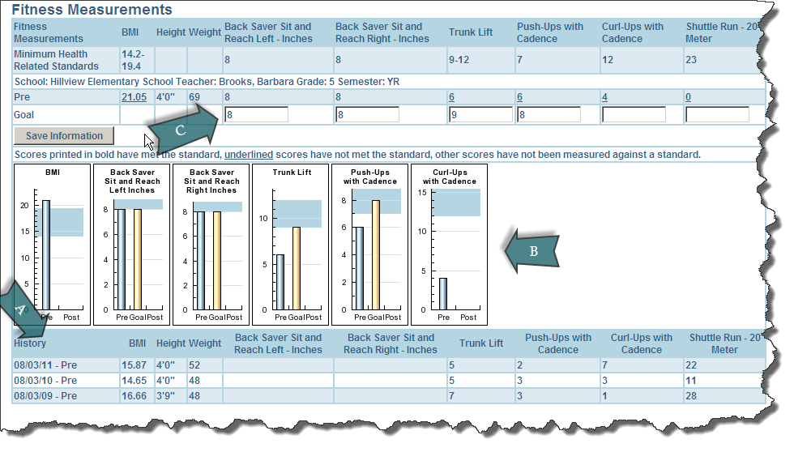

Your Username ___Student ID NUMBER

Your Password ___Student LAST NAME

